# CS 255 System Design Document Template

## UML Diagrams

### UML Use Case Diagram

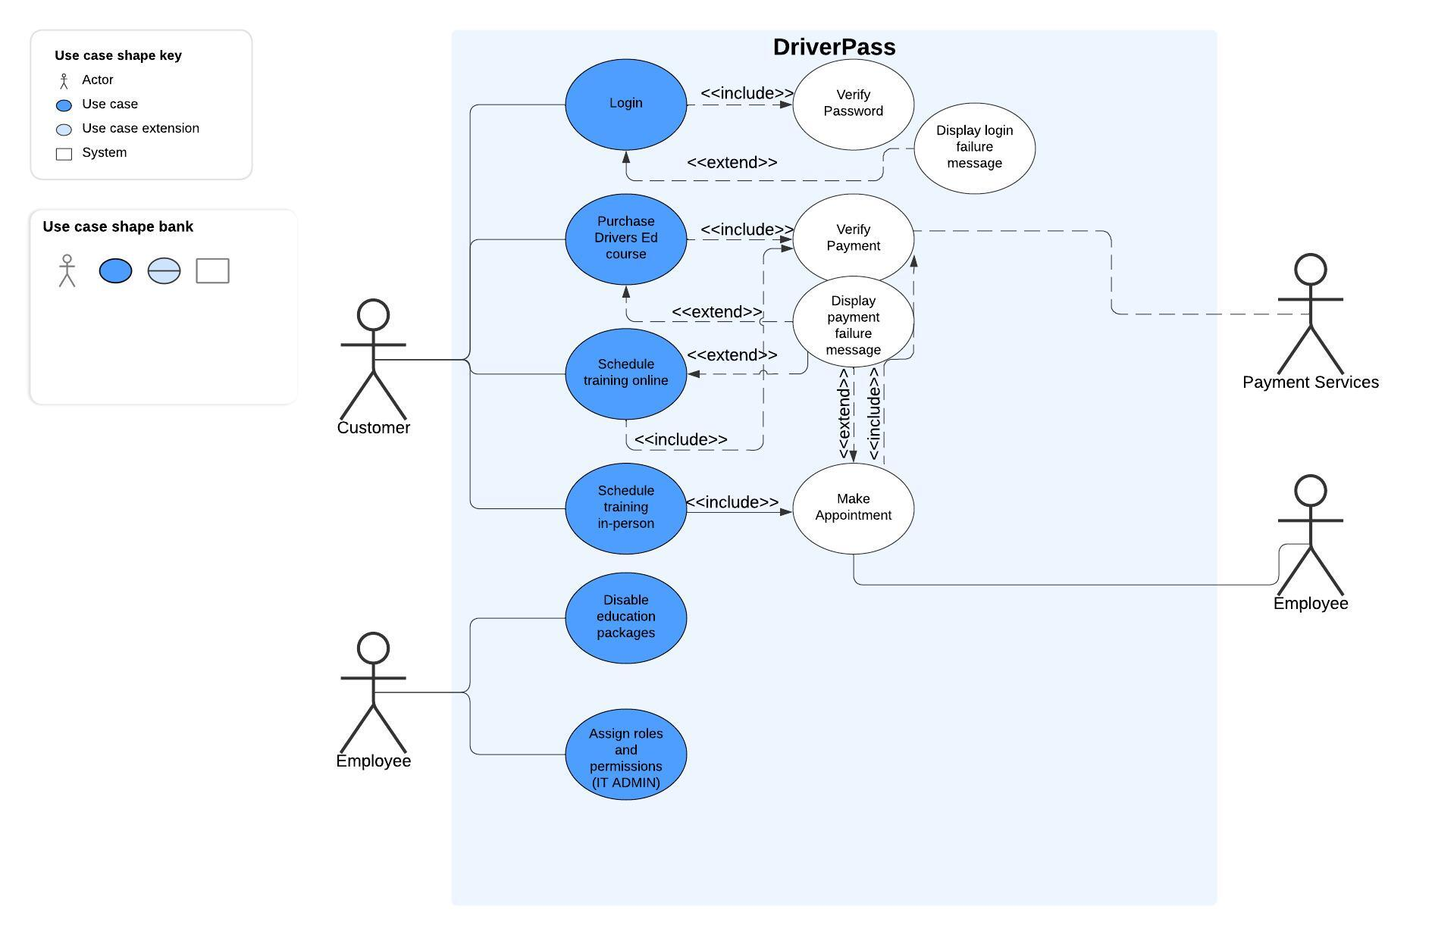

### UML Activity Diagrams

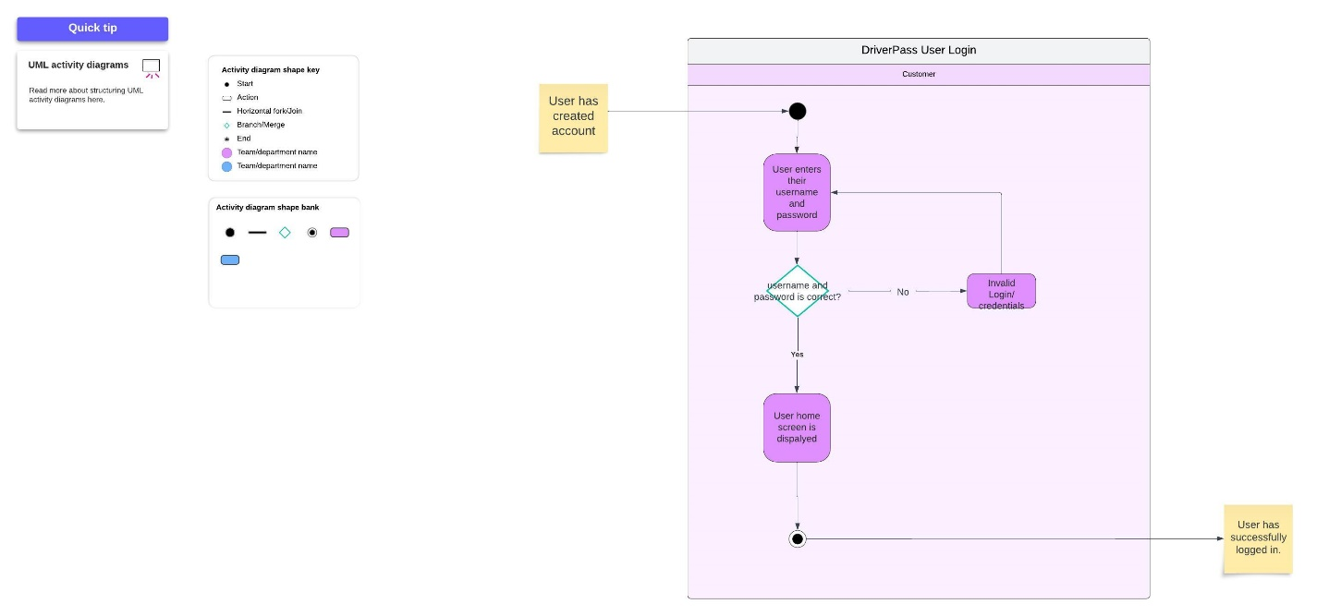

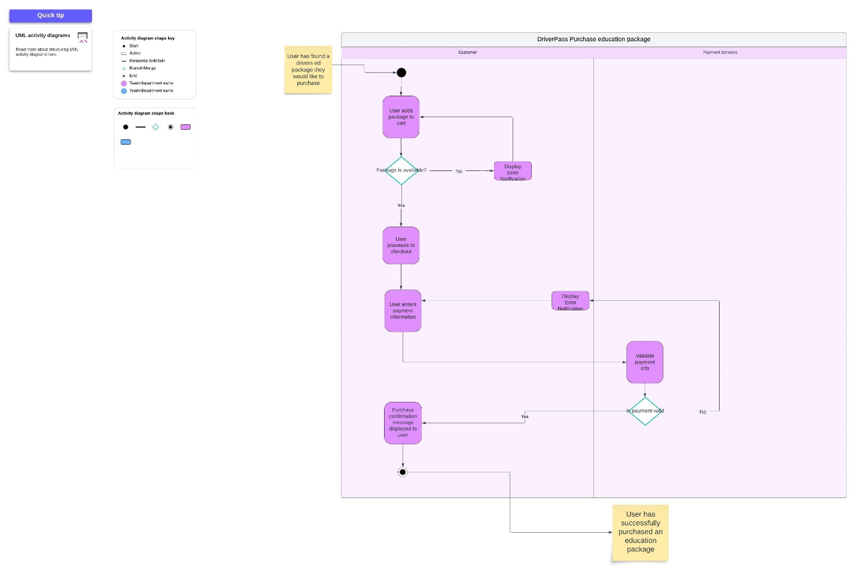

### UML Sequence Diagram

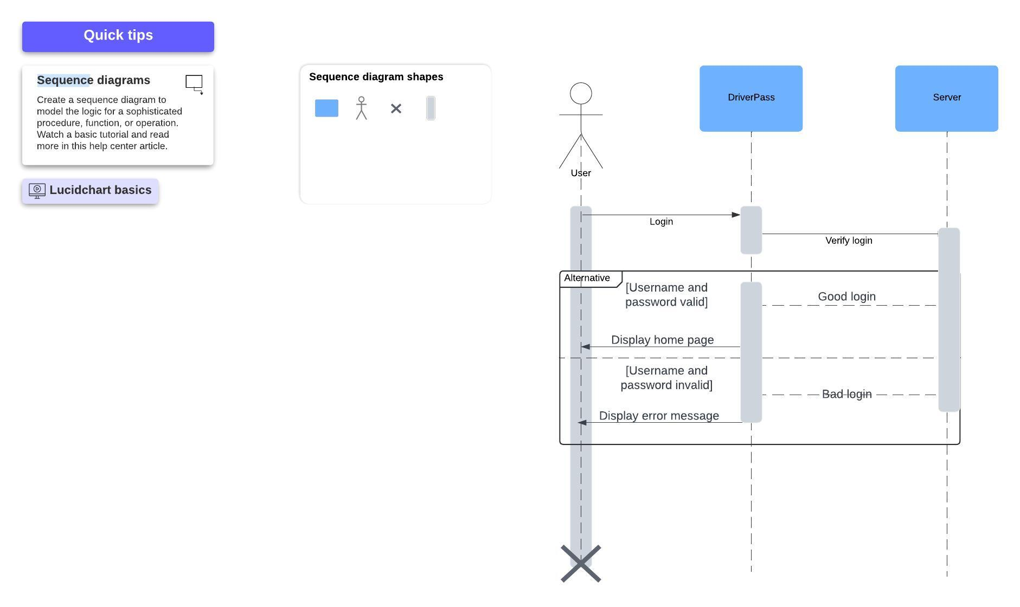

### UML Class Diagram

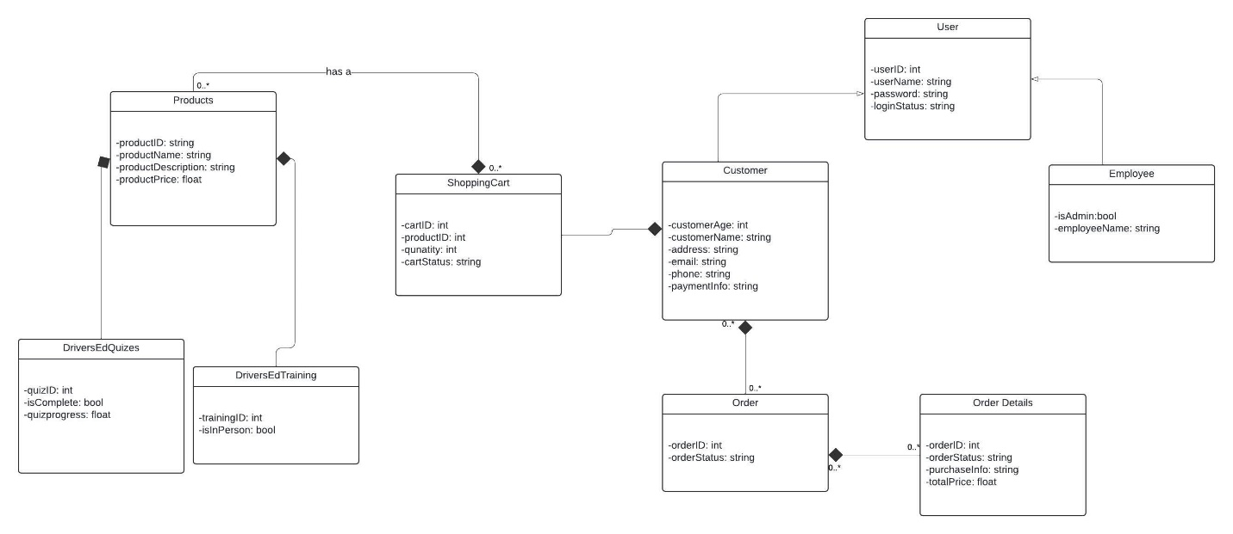

## Technical Requirements

Based on these diagrams, our system contains several technical requirements that are necessary for the DriverPass system design. First, our users need to interact with the internet and will require a cellphone, computer, or any device with access to the internet. Next, they will need a sufficient internet speed to use our system as intended. User’s might also need a means of transport to the physical location is they elect to take in-person drivers ed courses. As long as the user of DriverPass has a device that can access the internet with decent internet speeds, they should be able to use our web application.